|  |  |
| --- | --- |
| j0236335 | Eastern Goldfields College  Year 12 Investigation Mathematics Methods  Area Under A Curve – Validation Test  Time Allowed: 60 minutes  Total marks 46 Name: |

**1.** Below is the graph of a journey **[6 marks]**

a) What is the area of each square in the grid and what does it represent?

b) What is the area under the curve?

c) What is the significance of your answer above to the journey?

**2.** Below is the graph of another journey **[8 marks]**

How far did the person travel:

a) in the first 10 seconds

b) between 10 and 40 seconds

c) during the first 80 seconds

d) During what time period did the person have the greatest acceleration (positive or negative - explain your answer)

e) When did the person have the greatest velocity?

3. Below is a graph of  **[7 marks]**

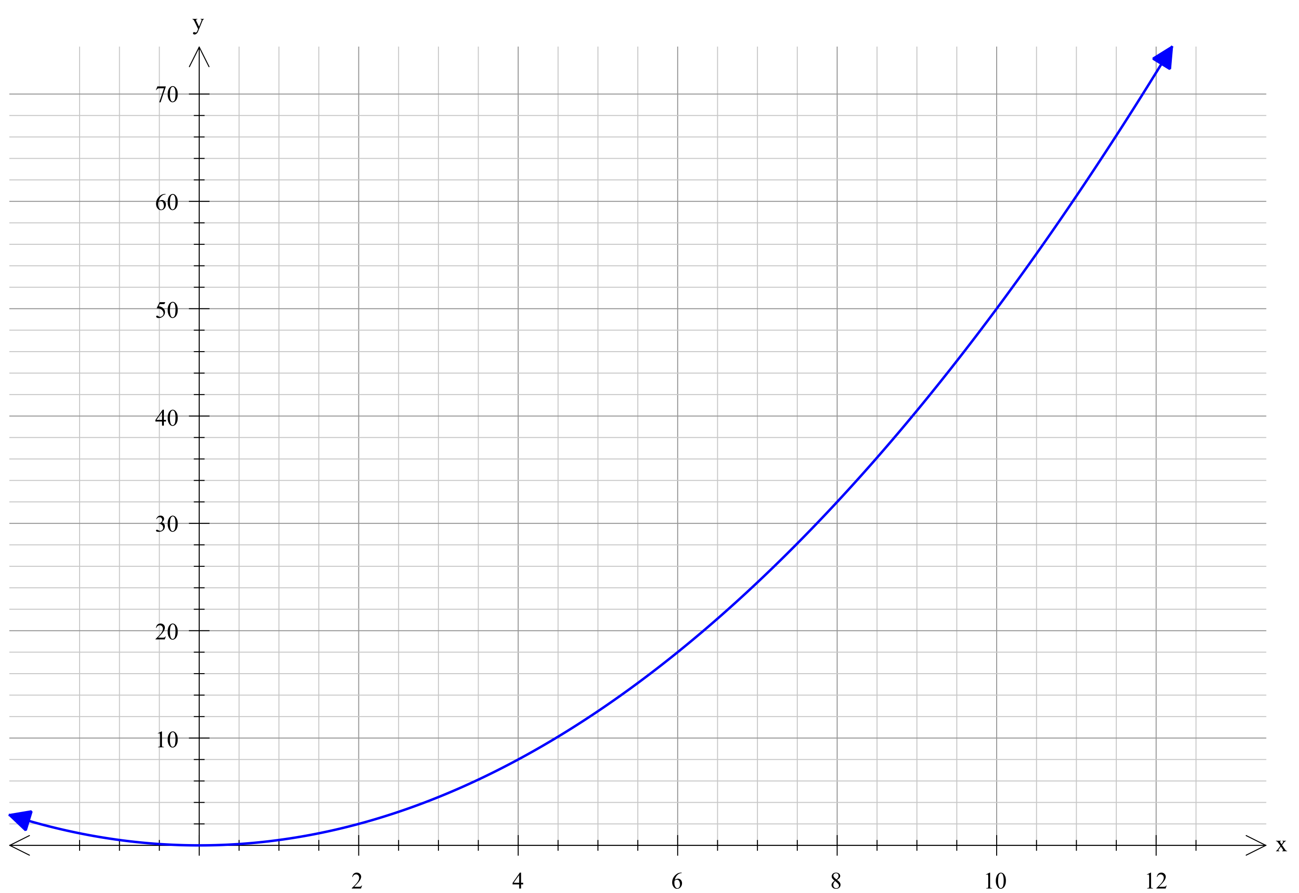

Approximate the area between the curve and the x-axis from 0 to 10, using intervals of 2, and then:

a) find the sum of the left hand rectangles.

b) find the sum of the right hand rectangles

c) Find the approximate area between the curve and the x-axis from 0 to 10.

d) What would be the approximate area between the curve and the x-axis from 2 to 10?

**4.** The area under a speed graph gives us the distance travelled. **[6 marks]**

Thinking about the relationship between speed and distance, answer the following questions.

A rocket is travelling with a speed given by v = 4t3 + 6t2 + 10 m/s 0s ≤ t ≤ 100s

a) Does the rocket ever travel with a negative speed? Justify your answer.

b) How far would the rocket travel during the 100s trip?

c) How far would the rocket travel between t = 40 and t = 100s

**5.** Without counting squares (rectangles or any other shapes), find the area under the curve ; **[5 marks]**

a) between the interval 0 ≤ x ≤ 10?

b) between the interval 4 ≤ x ≤ 10?

**6.** **[8 marks]**

A similar approach to the left hand rectangles and right hand rectangles can be used to find the approximate area of a circle.

a) If we consider a circle of radius 10cm. We could break it up into 6 internal triangles and 6 external triangles. Find the area of each triangle and hence find an approximation for internal area of the circle.

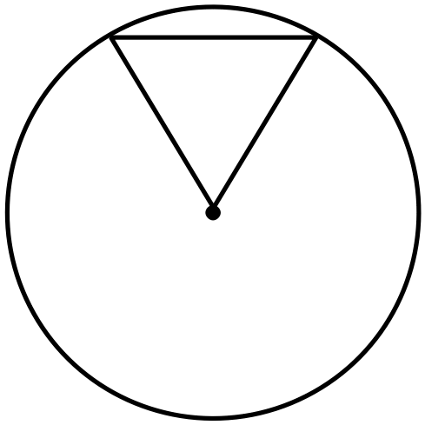

b) Now break it up into 6 external triangles. Find the area of each triangle and hence find an approximation for external area of the circle.

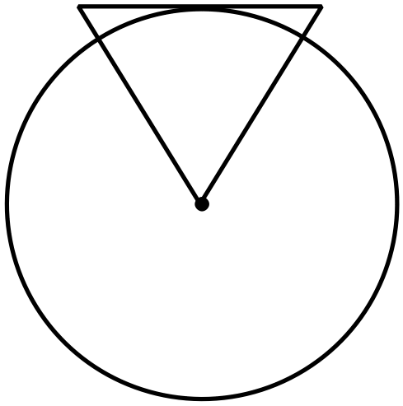

c) By averaging these results, find a good approximation to the area of the circle, radius 10cm.

d) How does this compare to the exact area of the circle?

7. Repeat question 6 only this time use 12 triangles instead of 6. **[6 marks]**